General Information

WRICEF number | INT.01.04.01
WRICEF type | Workflow / Report / Interface / Conversion / Enhancement / Forms
Project name | KPN Coupa Implementation
Application module | Contract
Program name | Coupa Contract Integration
Author name | Yossy Rivianto
Create date | 08.12.2025
Priority | High | Medium | Low
Complexity Assessment | High | Medium | Low
Processing period | Daily | Weekly | Monthly
Processing period | Annual | Other:
Processing period | N/A
Planned Due date
Remarks

Functional Specification Approval/Sign-off
Role | Name | Date | Signature
Functional | Yossy Rivianto | 08.12.2025
Functional Team Lead
ABAP
Integrator
Project Advisor

Users
Username | Role | Remark
 | Business tester
 | Requirement Authority
 | Benefit Owner/Sponsor

Document Revision History
Revision Date | Version | Summary of Change | Revised by

Table of Content

General Information 1
Document Revision History 2
1. Purpose 6
2. Business Requirement/ To Be Process 7
3. Detail Function Requirement 7
3.1. Process Logic for Data Retrieval and Conversion 7
3.2. Field Mapping Data SAP S/4 HANA to Coupa 7
3.3. Integration Information. 8
4. Test Scenarios 8

List of Tables

Table 1 Mapping Data Coupa Contract Integration for Contract Header 8
Table 2 Mapping Data Coupa Contract Integration for Contract Item/Supplier Item 9
Table 3 Detail information for Coupa Contract integration 9

List of Figures

Figure 1 Detail for program flow process requisitions in first point 6

1. Purpose
In conjunction with the implementation of Coupa for the procurement process, this document explains the flow of Coupa Contract and SAP Outline Agreement

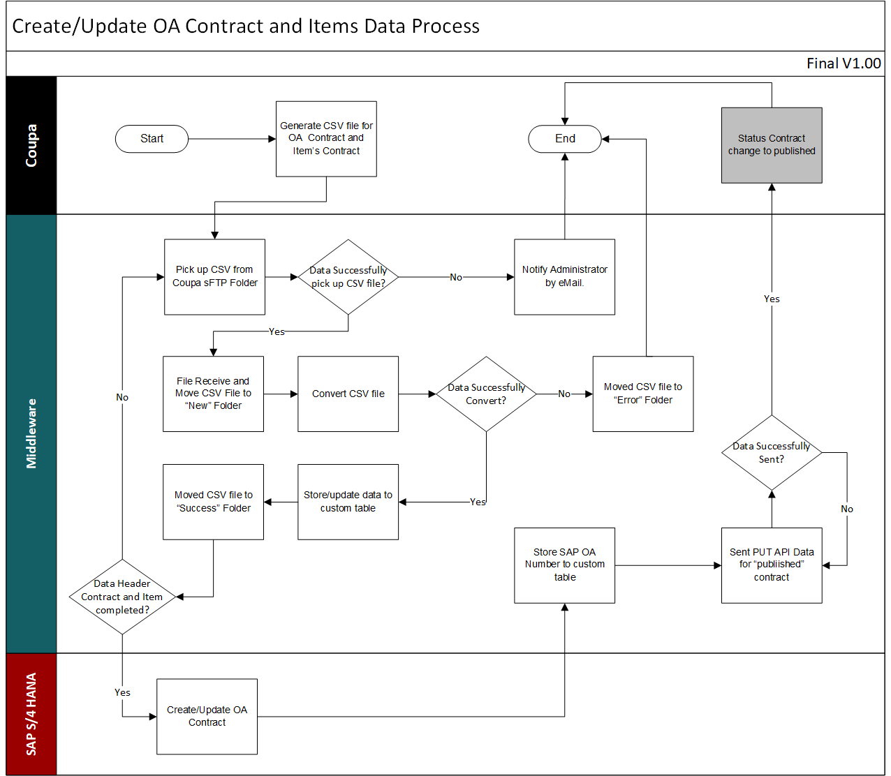
Figure 1 Detail for program flow Coupa Contract Integration

2. Business Requirement/ To Be Process
The Outline Agreement (OA) is initiated in Coupa with a status of Completed. Upon reaching this status, a CSV file is generated and retrieved by the middleware. The middleware then transmits the data to SAP to create the corresponding SAP Outline Agreement. Once the SAP Outline Agreement is successfully created and released, the middleware updates the Coupa OA status to Published.

3. Detail Function Requirement

Process Logic for Purchase Order Integration
Coupa will be store file contract header and supplier items in sFTP in the separate folder with condition below:
  - Status = Completed
  - Type = Outline Agreement

The middleware should retrieve the CSV file from the sFTP server and store the data into separate custom tables for Contract Header and Supplier Item records with index field as below:
- Contract Header is Contract ID
- Supplier Item is Contract ID and Coupa Supplier Internal Number (CSIN)

Process logic for the Contract Header when the parent_number field is blank.:
- Middleware Validation Process. The middleware shall validate the existence of the same Contract Number between the following sources:
- Contract CSV → Contract custom table
- Supplier Item CSV → Supplier Item custom table
If the same Contract Number exists in both tables, the middleware shall update the field:
- “Ready_to_Create_SAP_OA” = ‘Yes’
Otherwise:
- “Ready_to_Create_SAP_OA” = ‘No’
This field must exist in both custom tables (Contract and Supplier Item).
- SAP Interface Selection Logic. The SAP interface program shall select records from the middleware custom table based on the following criteria:
  - Ready_to_Create_SAP_OA = ‘Yes’
  - SAP OA Number is blank
The program shall then create the SAP Outline Agreement (OA) based on these records.
- Post SAP OA Creation Process (Middleware). After the SAP Outline Agreement is successfully created in SAP, the middleware shall perform the following updates:
  - SAP Contract Number should be updated in contract custom table
  - SAP Contract Number and SAP Contract Line Number should be updated in supplier item custom table. Also need to input SAP OA that combine between SAP Contract Number and SAP Contract Line Number with “/’ as separator
SAP Description | Sample Data | Description |  | Sample Data
SAP Contract Number | 440000000091 | SAP Contract Number |  | 440000000091
SAP Contract Line Number | 10 | SAP Contract Line Number |  | 10
 |  | SAP OA Line |  | 440000000091/10
Table 1 Sample Data for Supplier Item Custom Table
- PUT API Call to Coupa for Supplier Items. The middleware shall trigger PUT APO API calls to Coupa for Supplier Items using the following details:
API Endpoint:
https://kpn-test.coupahost.com/api/supplier_items/(CSIN)
Body:
{
"id": (CSIN),
"custom-fields": {
"sap-oa-line": "(SAP_OA_LINE)"
}
}
Noted:
CSIN (Coupa Supplier Internal Number) and SAP OA Line from supplier item custom table.

- PUT API Calls to Coupa for Contract Header. The middleware triggers two sequential PUT API calls to Coupa for the Contract Header with a 3-second interval between each call.
API Endpoint:
https://kpn-test.coupahost.com/api/contracts/(Contract ID)
          - Pulish Contract
Body:
{
"id": (Contract ID),
"status": "published"
}
Noted:
Contract ID from contract header custom table.

          - Update SAP OA Number
Body:
{
"id": (Contract ID),
"custom-fields": {
"sap-oa": (SAP OA #)
}
}
Noted:
SAP OA Number from contract header custom table.

Process logic for the Contract Header when the parent_number field is not blank:
- Middleware Validation Process. Once Data contract Header store into custom table, Middleware needs to update “Ready to Update SAP OA” field to ‘Yes’
- SAP Interface Selection Logic. The SAP interface program shall select records from the middleware custom table where:
  - Ready to Update SAP OA = ‘Yes’
The program shall then update the SAP Outline Agreement (OA) based on these records.
- Post SAP OA Update Process (Middleware). After the SAP Outline Agreement is successfully updated “Finished Update SAP OA” field to ‘Yes’
- PUT API Calls to Coupa for Contract Header. The middleware triggers PUT API calls to Coupa for the Contract Header
API Endpoint:
https://kpn-test.coupahost.com/api/contracts/(Contract ID)
          - Pulish Contract
Body:
{
"id": (Contract ID),
"status": "published"
}
Noted:
Contract ID from contract header custom table.

Process logic for the Supplier Items:
- Middleware Validation Process. The middleware shall validate the existence of the SAP OA Line field and continue with logic below:
  - If SAP OA Line is blank. Middleware needs to check SAP OA # in Contract Header table. If SAP OA # is blank, then trigger for SAP OA Creation. Otherwise, it triggers SAP OA Update and adds new items.
  - If SAP OA Line is not blank. This is triggering process SAP OA Update with new data.
- SAP Interface Selection Logic. The SAP interface program is based on logic above.
- Post SAP OA Update Process (Middleware). After the SAP Outline Agreement is successfully updated “Finished Update SAP OA” field to ‘Yes’.
- PUT API Calls to Coupa for Supplier Items. The middleware triggers PUT API calls to Coupa for the Contract Header
API Endpoint:
https://kpn-test.coupahost.com/api/supplier_items/(CSIN)
Update SAP OA Line
Body:
{
"id": (CSIN),
"custom-fields": {
"sap-oa-line": (SAP OA Line)
}
} Noted:
Coupa Supplier Internal Number (CSIN) from supplier item custom table.
SAP OA Line from supplier item custom table.

Field Mapping Data
Here is the mapping of data between SAP S/4 HANA, Middleware and Coupa for Contract Header:
SAP Description | SAP Technical Name | Description | Middleware-Technical Name | Type | CSV Field Name
SAP OA# | EKKO-EBELN | SAP OA# | EBELN | String(255) | SAP OA
Your Reference | TBD | Coupa Contract Name | CTR_NAME | String(255) | Contract Name
TBD | TBD | Contract # | CTR_NUM | String(255) | Contract #
TBD | TBD | Contract ID | CTR_ID | Integer | ID
 |  | Contract Type | CTR_TYPE | String(10) | contract_type name
 |  | Status | CTR_STAT | String(20) | Status
 |  | Owner Login | OWN_LOGIN | String(50) | Owner Login
Material Group |  | Commodity Name | COMM_NAME | String(50) | contract-detail-commodity-name
 |  | Created Date | CTR_CDAT | Date | Created Date
Supplier Site Number | EKKO-LIFNR | Supplier Site Number | LIFNR | Integer | Supplier Number
Supplier Name | LFA1-NAME1 | Supplier Name | LFA1-NAME1 | String(255) | Supplier
Purchasing Group | EKKO-EKGRP | Purchasing Group | EKGRP | String(100) | purchasing_group external_ref_code
Starts | EKKO-KDATB | Starts | KDATB | Date | Starts
Content Groups | EKKO-EKORG | Content Groups | EKORG | String(255) | Content Groups
Expires | EKKO-KDATE | Expires | KDATE | Date | Expires
 |  | Created By Login | CTR_CLOG | Integer | Created By Login
Currency Code | EKKO-WAERS | Currency Code | WAERS | String(3) | Currency Code
Payment Term | EKKO-ZTERM | Payment Term | ZTERM | String(4) | payment_term code
Shipping Term | EKKO-INCO1 | Shipping Term | INCO1 | String(3) | shipping_term code
Maximum Spend | EKKO-KTWRT | Maximum Spend | KTWRT | Integer | maximum_value
 |  | Updated Date | CTR_UPDT | Date | Updated Date
Item Category | EKPO-PSTYP | Item Category | EKPO-PSTYP | String(10) | item_category
Company Code | EKKO-BUKRS | Company Code | BUKRS | String(50) | company_code external_ref_code
 |  | Ready to Create SAP OA | CRT_SAPOA | String(10)
 |  | Ready to Update SAP OA | UPD_SAPOA | String(10)
 |  | Amendment Contract Type | AMD_CTR_TY | String(10) | amended_contract_type
 |  | Parent Contract ID | CTRPA_ID | Integer | parent id
 |  | Parent Contract Name | CTRPA_NAME | String(255) | parent name
 |  | Parent Contract Number | CTRPA_NUM | String(255) | parent number

Table 1 Mapping Data Coupa Contract Integration for Contract Header
SAP Description | SAP Technical Name | Description | Middleware-Technical Name | Type | CSV Field Name
 |  | Contract Number | CTM_CNUM | String(255) | Contract number
SAP Contract Number | EKKO-EBELN | SAP Contract Number | EBELN | String(10)
SAP Contract Line Number | EKKO-EBELP | SAP Contract Line Number | EBELP | String(10)
 |  | SAP Contract No/Line No | SAP_OA_LINE | String(20) | SAP OA Line#
Name |  | Name | CTM_NAME | String(255) | Name
Plant |  | Plant | CTM_PLANT | String(255) | Supplier Part Num
Supplier Aux Part Num |  | Supplier Aux Part Num | SUP_APNM | String(255) | Supplier Aux Part Num
Description |  | Description | CTM_DESC | String(255) | Description
Material Number | EKPO-MATNR | Item Commodity Sap Code | EKPO-MATNR | Need to add | Item Number
UOM Code | EKPO-MEINS | UOM Code | EKPO-MEINS | String(50) | UOM Code
Price | EKPO-NETPR | Price | EKPO-NETPR | decimal(30,3)
Price Per | EKPO-PEINH | Price Per | PRICE_PER | decimal(30,3) | Price Per
 |  | Price Value | PRICE_VALUE | decimal(30,3) | Price
Currency | Currency only on header table | Currency | Currency only on header table | String(3) | Currency
Supply Quantity |  | Supply Quantity | SUP_QTY | Integer | Supply Quantity
 |  | Availability | CTM_AVAIL | String(50) | Availability
 |  | Supplier Minimum Order Quantity | SUP_MOQ | Integer | Supplier Minimum Order Quantity
 |  | Created By (Login) | CTM_CLOG | String(255) | Created by (Login)
 |  | Updated By (Login) | CTM_ULOG | String(255) | Updated by (Login)
 |  | Created At | CTM_CDAT | Date | Created at
 |  | Updated At | CTM_UDAT | Date | Updated at
Material Group |  | CAT : Item Text | CTM_ITXT | String(255) | Item Commodity SAP Code
Incoterm Location |  | Incoterm Location | CTM_INCO | String(255) | Incoterm Location
TBD | TBD | Coupa Internal Number | CIN | String(20) | Coupa Internal Number
TBD | TBD | Coupa Supplier Internal Number | CSIN | String(20) | Coupa Supplier Internal Number
 |  | Ready to Create SAP OA | CRT_SAPOA | String(10)
 |  | Ready to Update SAP OA | UPD_SAPOA | String(10)
Table 2 Mapping Data Coupa Contract Integration for Contract Item/Supplier Item

Integration Information.
Traceability matrix | Description
Integration name | Coupa Contract Integration
Inbound/ Outbound | Outbound and Inbound
Integration pattern | sFTP and API
Type (batch, near real-time, real-time, excel upload, other)
Priority
Source system | Coupa
Target system | SAP
File source location for csv | sFTP [./Outgoing/Contract] (Contract Header)  sFTP [./Outgoing/Items] (Contract Items/Supplier Items)
Link destination location | https://kpn-test.coupahost.com/api/contracts/:id
Operation | Publish Coupa Contract
Table 3 Detail information for Coupa Contract integration

4. Test Scenarios
Client | Field Name | POSITIVE (P) / NEGATIVE (N)

No | Action/Description | T-Code | Input Data | Expected Result

<example for the expected test scenario>

